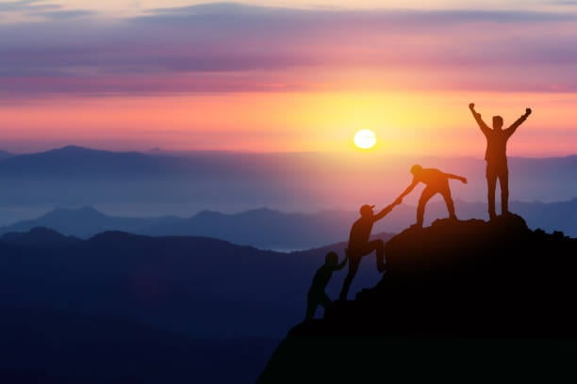

This image is very inspirational for it demonstrates teamwork. As the person celebrates their victory their friend is helping the other two people up the hill before celebrating their accomplishment. The height that the four people are standing on is taller than the mountains in the background which shows how big their accomplishment is. The setting sun makes me assume that it took the four people all day to accomplish victory.

